Gift of Happiness Foundation
Aid and Giving Project
Nakhon Sawan 5th to 9th December 2016

Every GoHF is unique, that is certain; however, Eckie the Clown departed from usual practice by arriving on his Royal Enfield motorcycle. All arrivals immediately had the desired effect, that of great excitement and interest from not only the children but also the teachers!
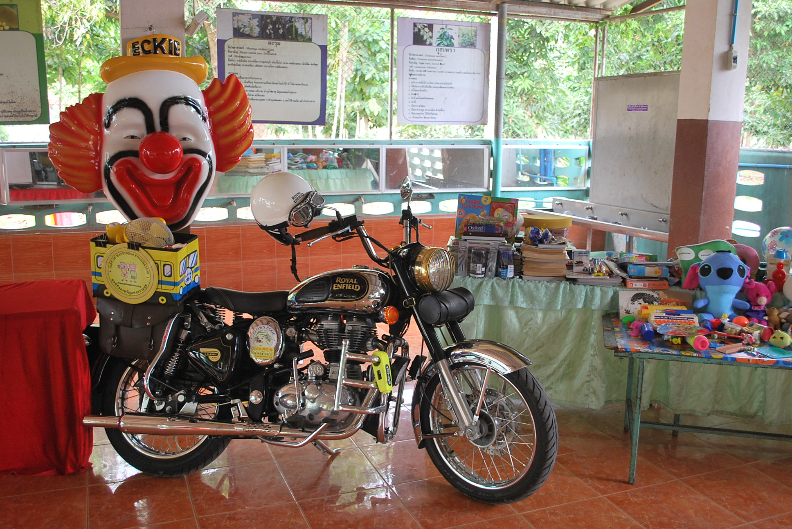

Loading of the donations, so generously given by so many just recently, started on Sunday and was completed on Monday morning. Two motorbikes were loaded into the Monroe pick-up truck, one Eckie’s and the other belonging to Antoine Van Innis, a long time supporter of GoHF. Antoine was enthusiastically joined by Ben Calberg and Charles Dobs, ensuring the Belgium contingent matched the British one - being Terry Sherwood, Martin Kneath and of course Eddie Haworth (aka Eckie the Clown) Director and Founder of the GoHF.

Arrival at Bonito Chinos Hotel, Nakhon Sawan, after an uneventful journey saw the group unload the motorbikes and prepare for an evening meal in preparation for the school visits planned for from Tuesday through to Friday morning. Khun Miki, a key figure in the Regent’s School administrative staff, was instrumental, along with her family (residents of Nakhon Sawan), in making contact with the schools and putting together the itinerary for the GoHF, thank you to her and to her family! All the schools are within about 25 km of the town centre and easily accessible. All schools are chosen deliberately to be relatively small Primary schools, whose children come from a poor background.

Wat Hat Salao School, the first school visited on Tuesday, has 93 students age range 2 to 12; donations of clothes for young children, teenagers and adults, toys, bedding and towels and educational equipment were handed over and naturally a madcap clown performance from Clown Eckie was thoroughly enjoyed by one and all.

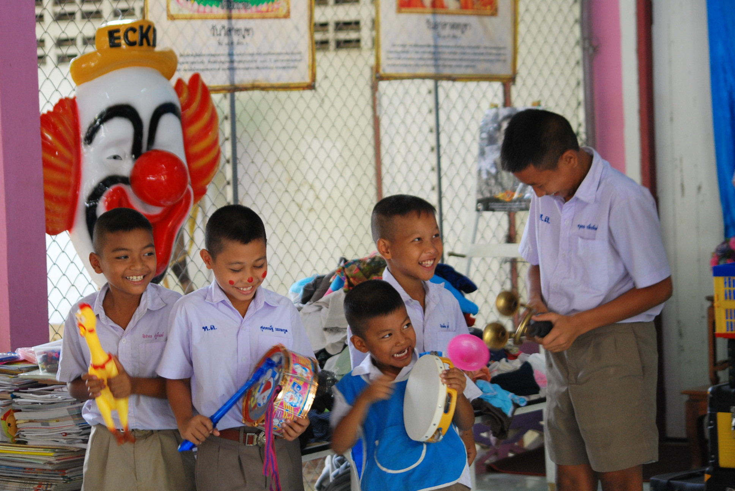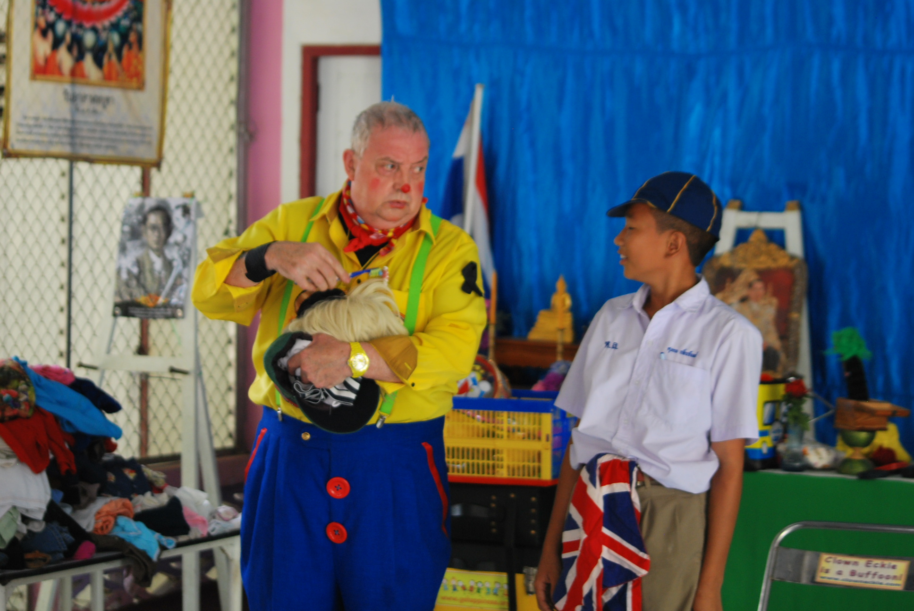
The second school visited during Tuesday afternoon was Wat Makkharangsarit School with 132 children aged 4 to 11 Years.
Donations of clothes for young children, teenagers and adults, toys, bedding and towels and educational equipment were handed over and naturally a madcap clown performance from Clown Eckie was thoroughly enjoyed by one and all.

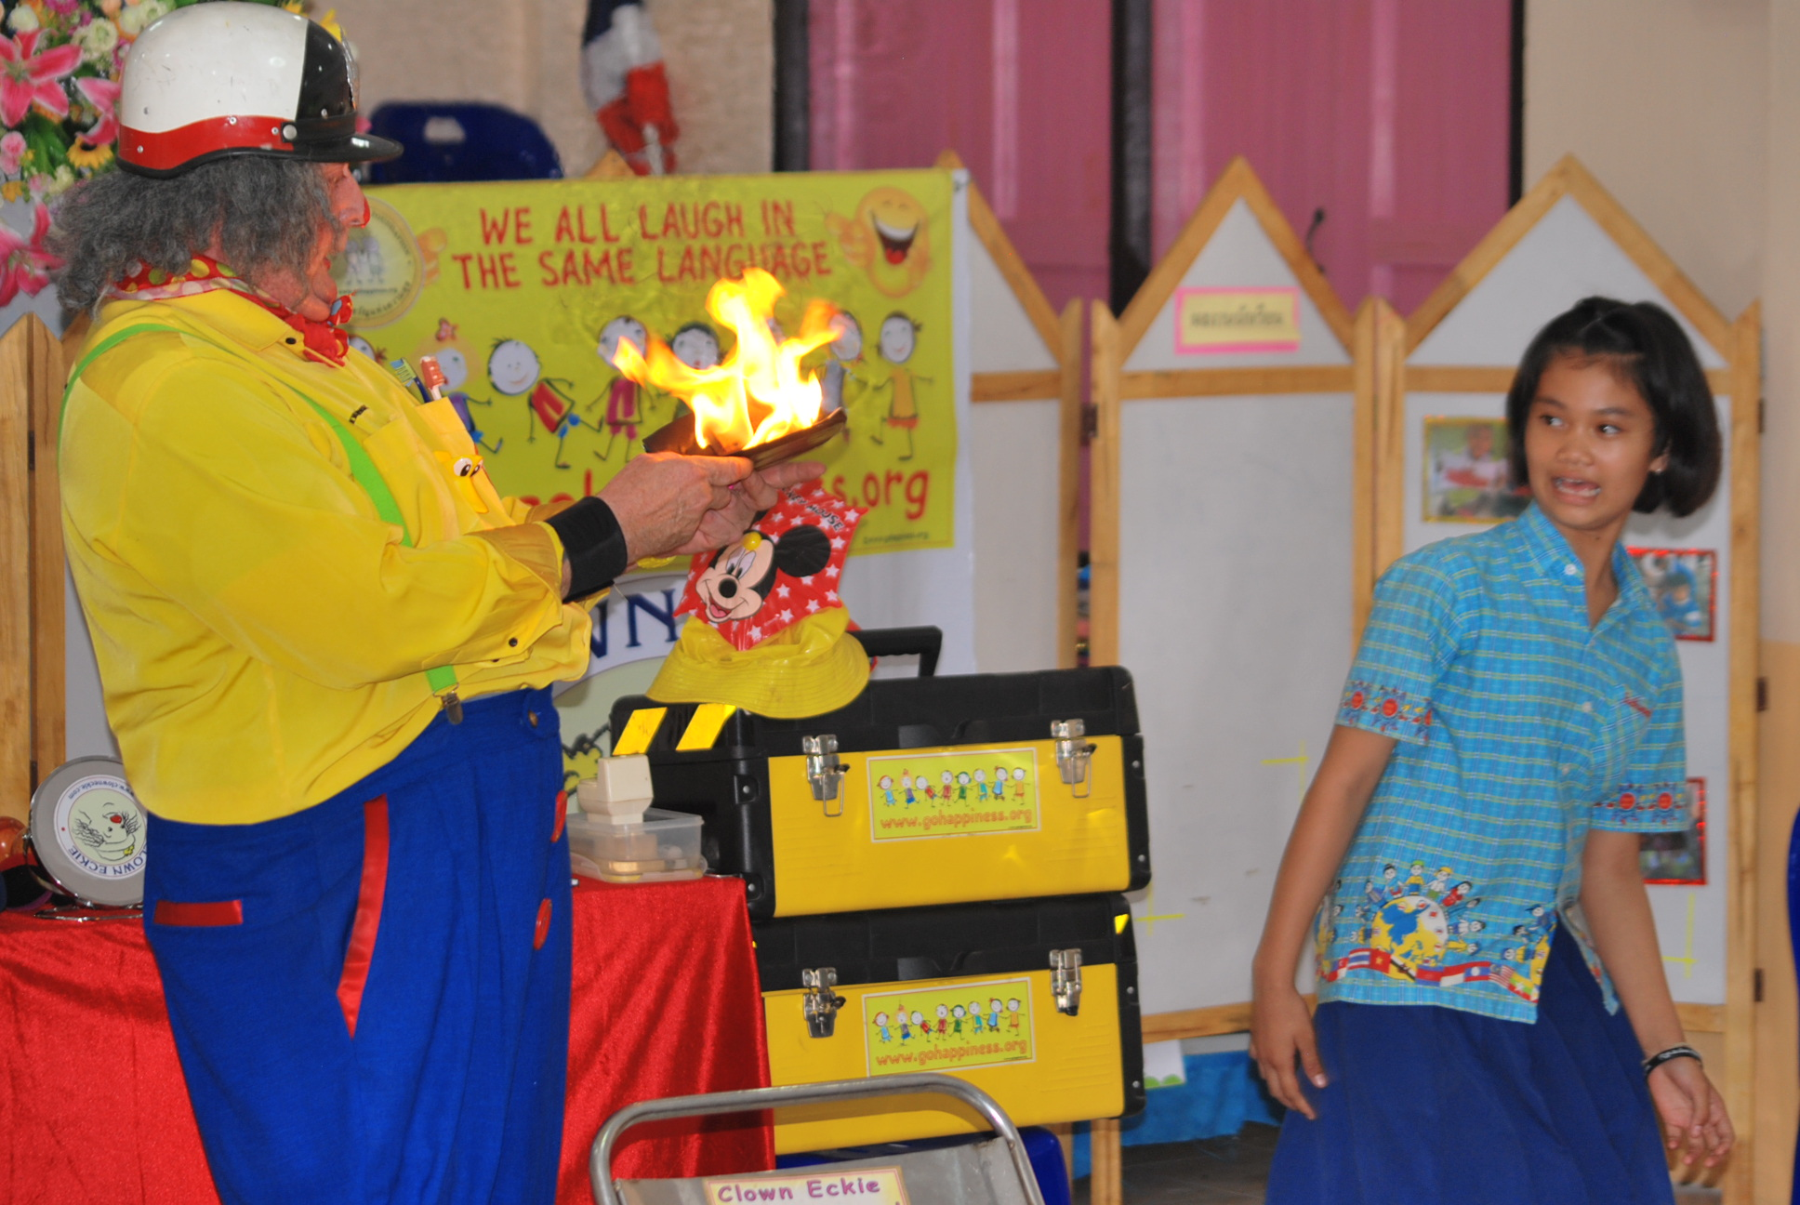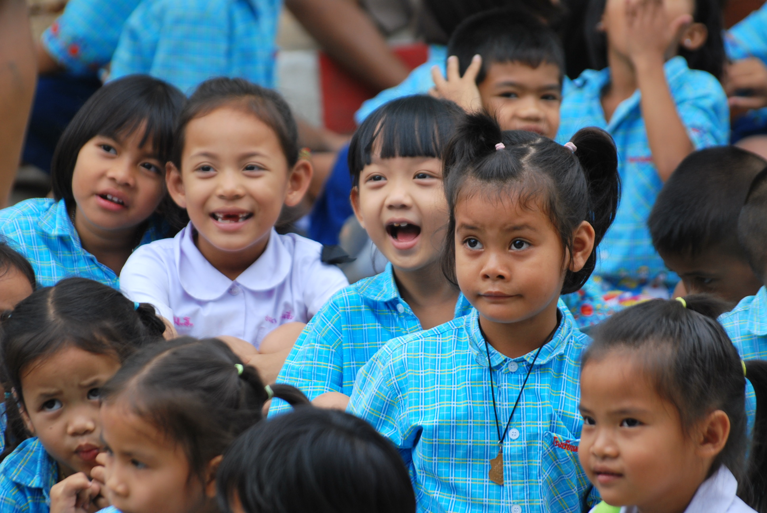

On our way to the next school, Khun Miki called to ask us where we were! The previous day’s HAPPINESS AND ENJOYMENT had been communicated to many of the schools in the area and the school’s to be visited wanted to be sure that we had not returned to Bangkok!!!
Wednesday saw us visit another Primary School with 130 students aged from 4 to 11 years, Mahapho Tai School. Donations of clothes for young children, teenagers and adults, toys, bedding and towels and educational equipment were handed over and naturally a madcap clown performance from Clown Eckie was thoroughly enjoyed by one and all.
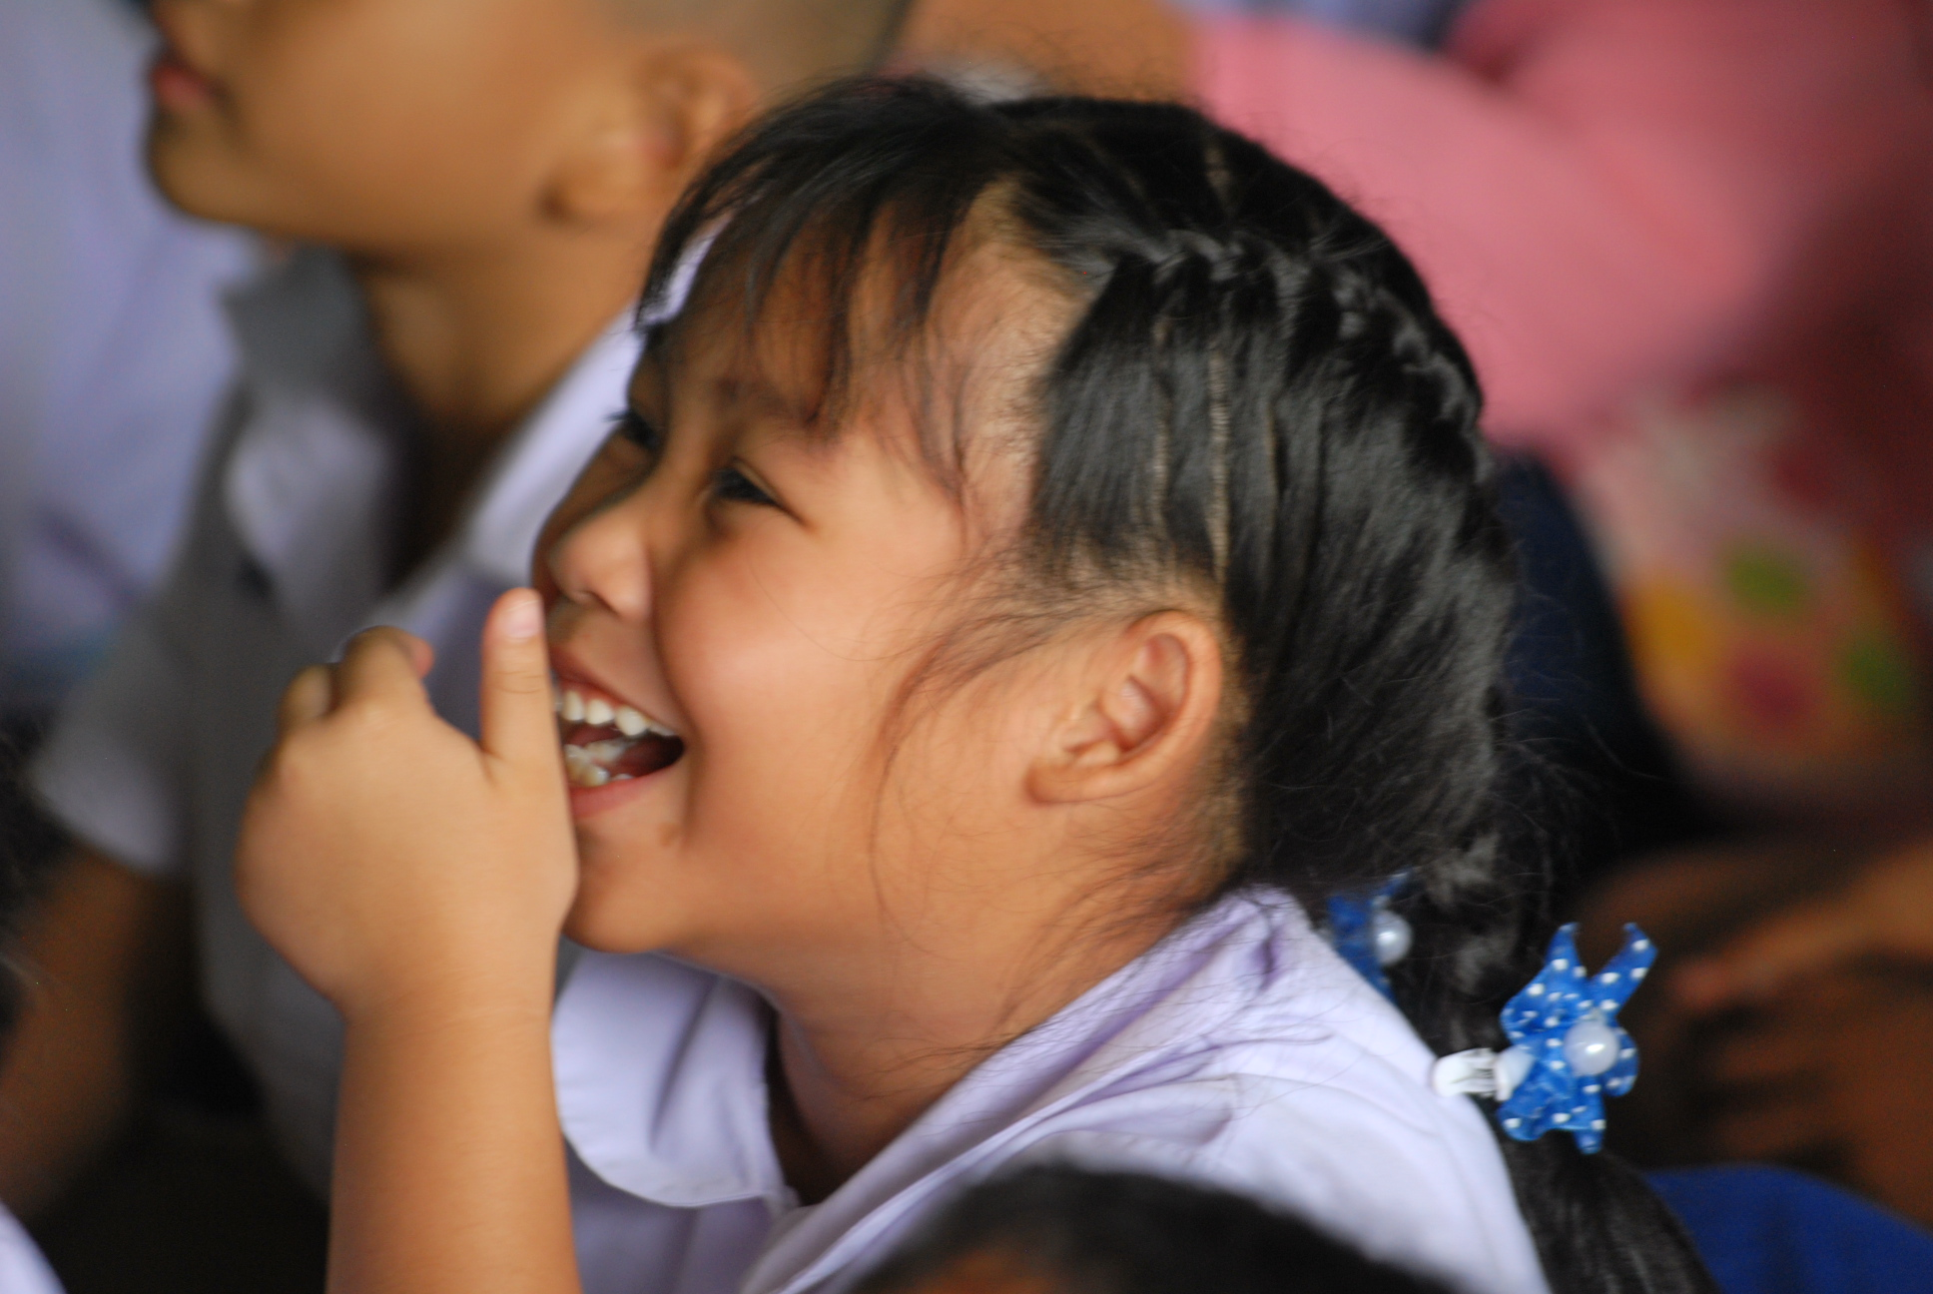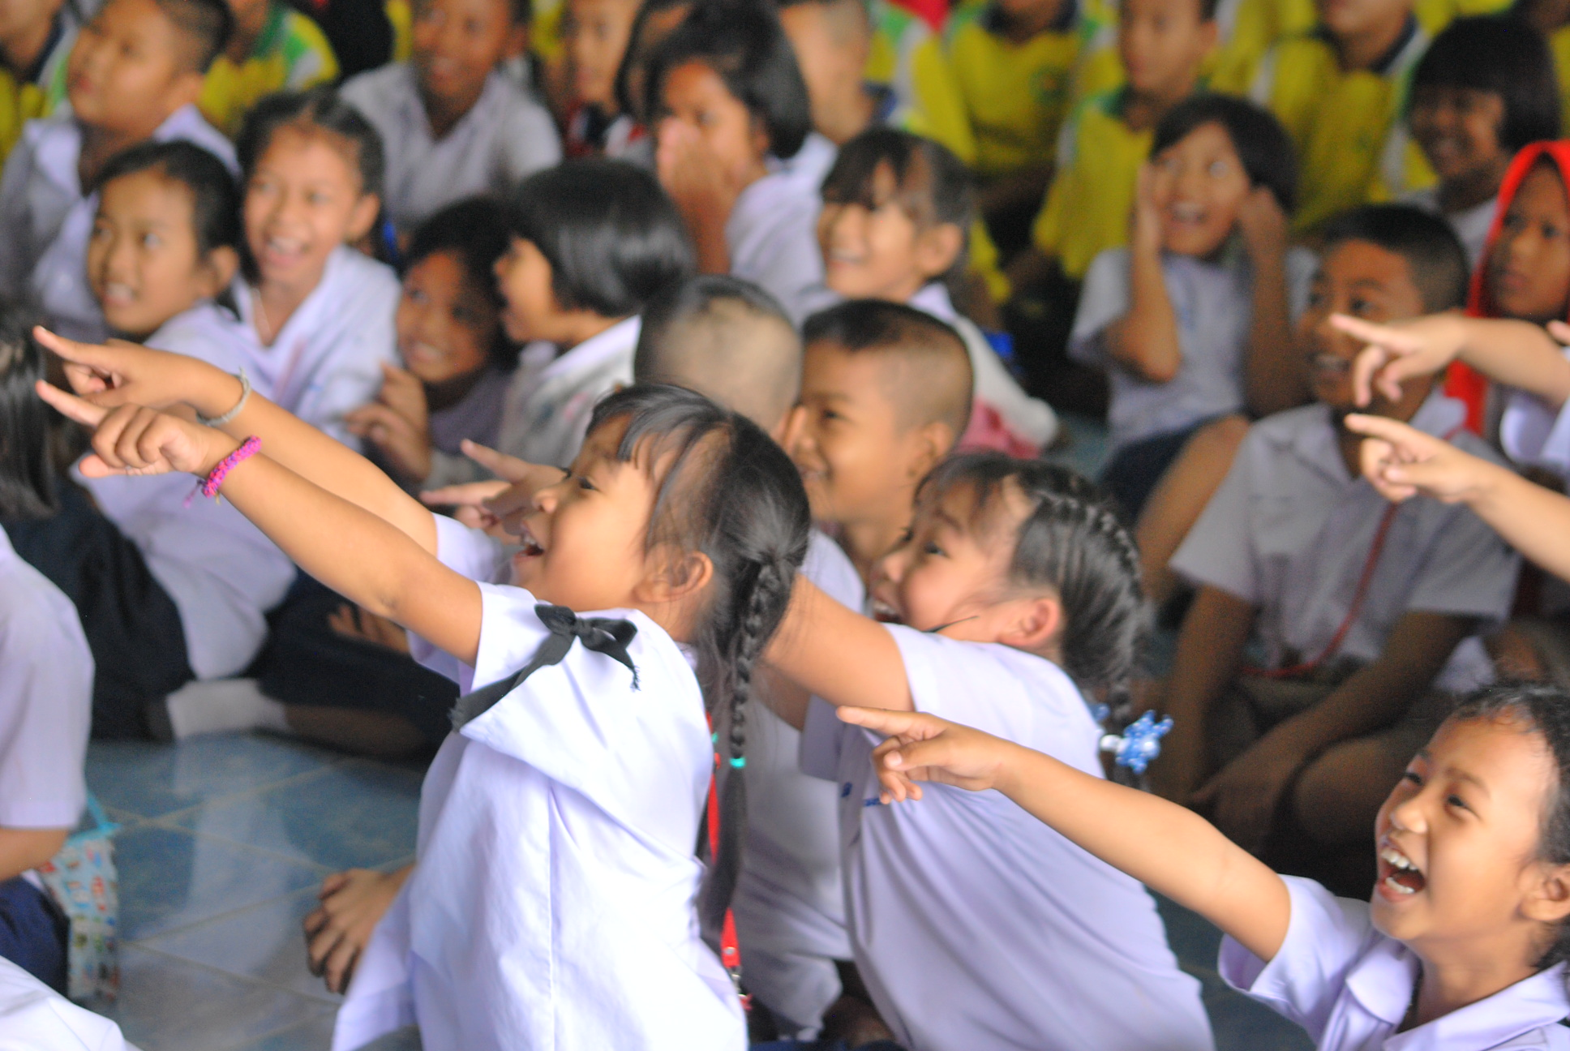

After lunch we drove a short distance to Mahapho Nuea School, 60 students aged to 4 to 11 years. Donations of clothes for young children, teenagers and adults, toys, bedding and towels and educational equipment were handed over and naturally a madcap clown performance from Clown Eckie was thoroughly enjoyed by one and all.

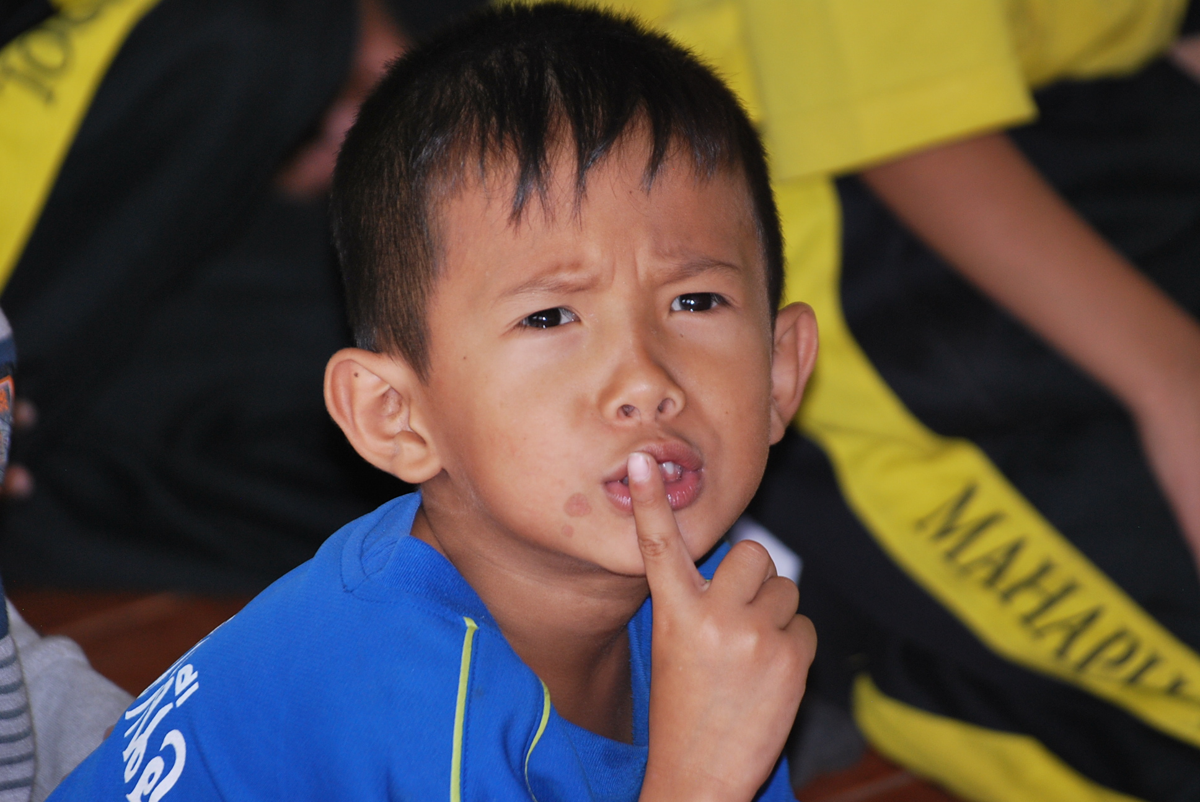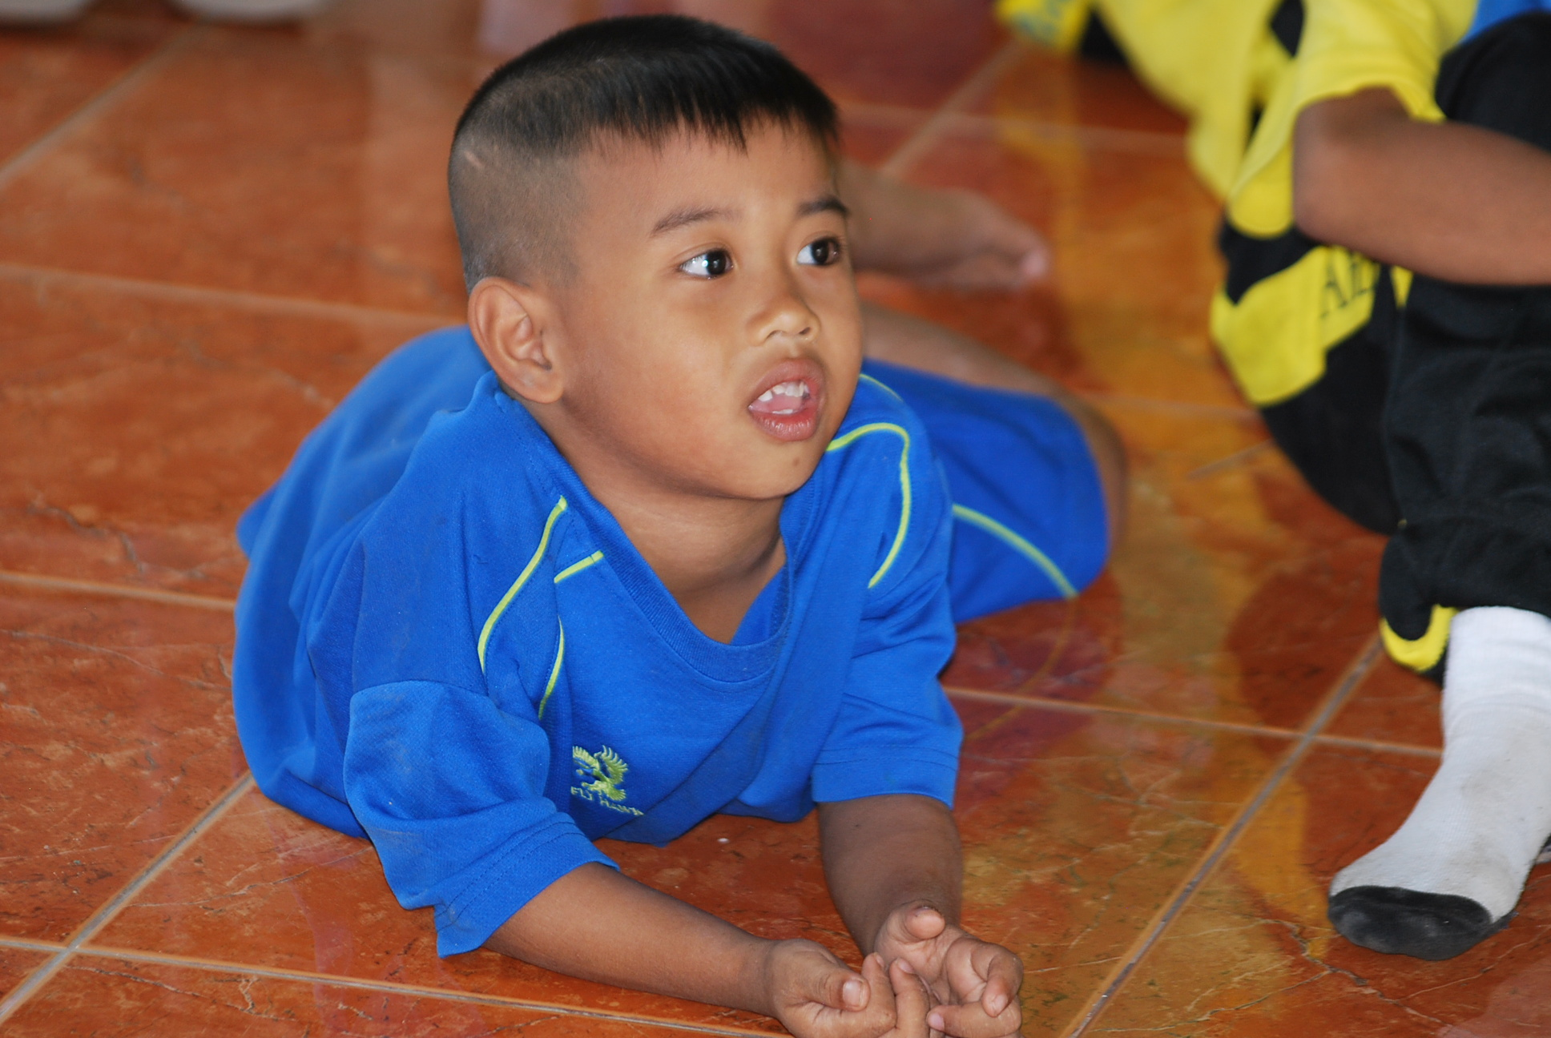

Thursday, in the original itinerary, had only one visit planned – the one to Ban Nong Hua Ruea School, 150 children 3.5 to 11 years.

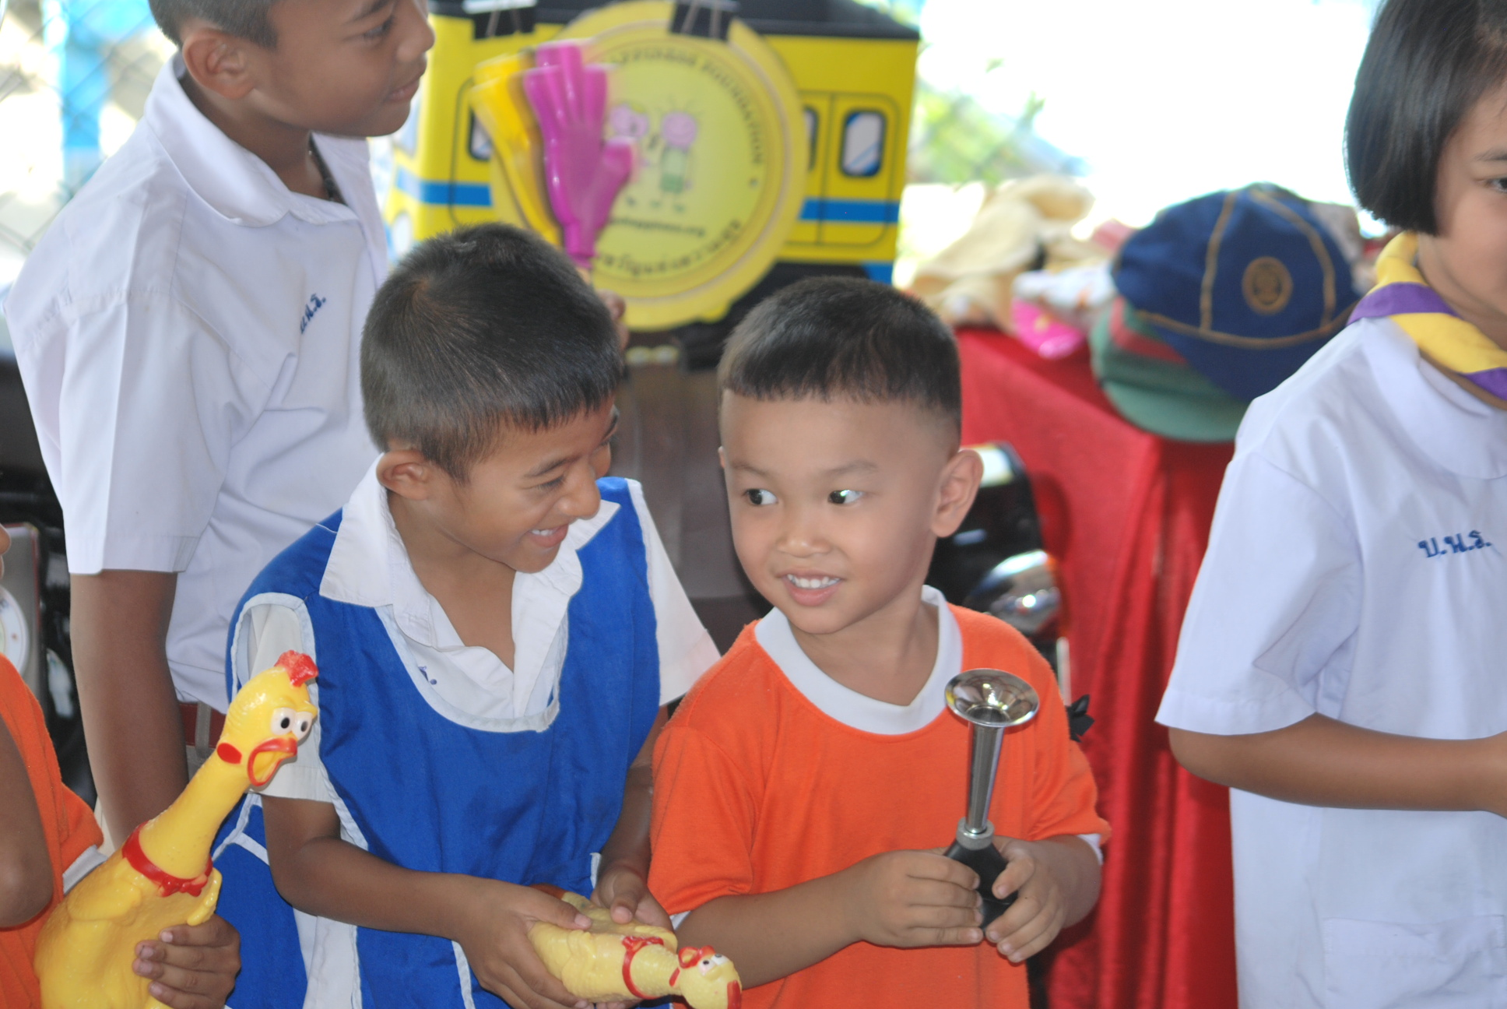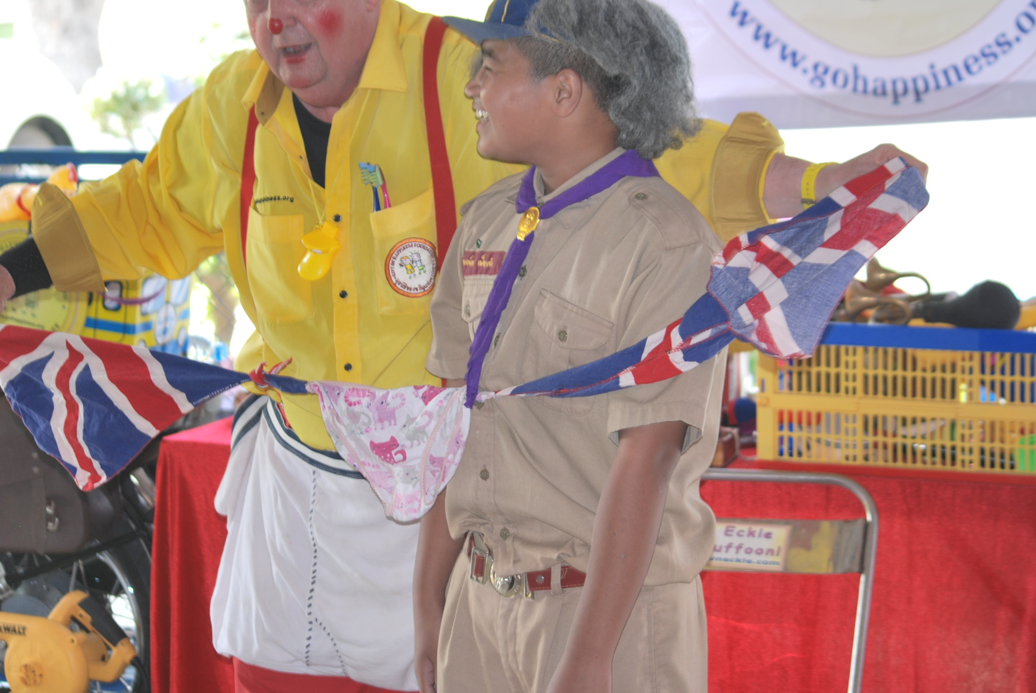

Donations of clothes for young children, teenagers and adults, toys, bedding and towels and educational equipment were handed over and naturally a madcap clown performance from Clown Eckie was thoroughly enjoyed by one and all.

During the morning, we were once again contacted by Khun Miki to ask if we were prepared to visit the gathering of Scouts and Guides for another show – we dutifully agreed and met up with Ban Nong Phaeng Phai School.

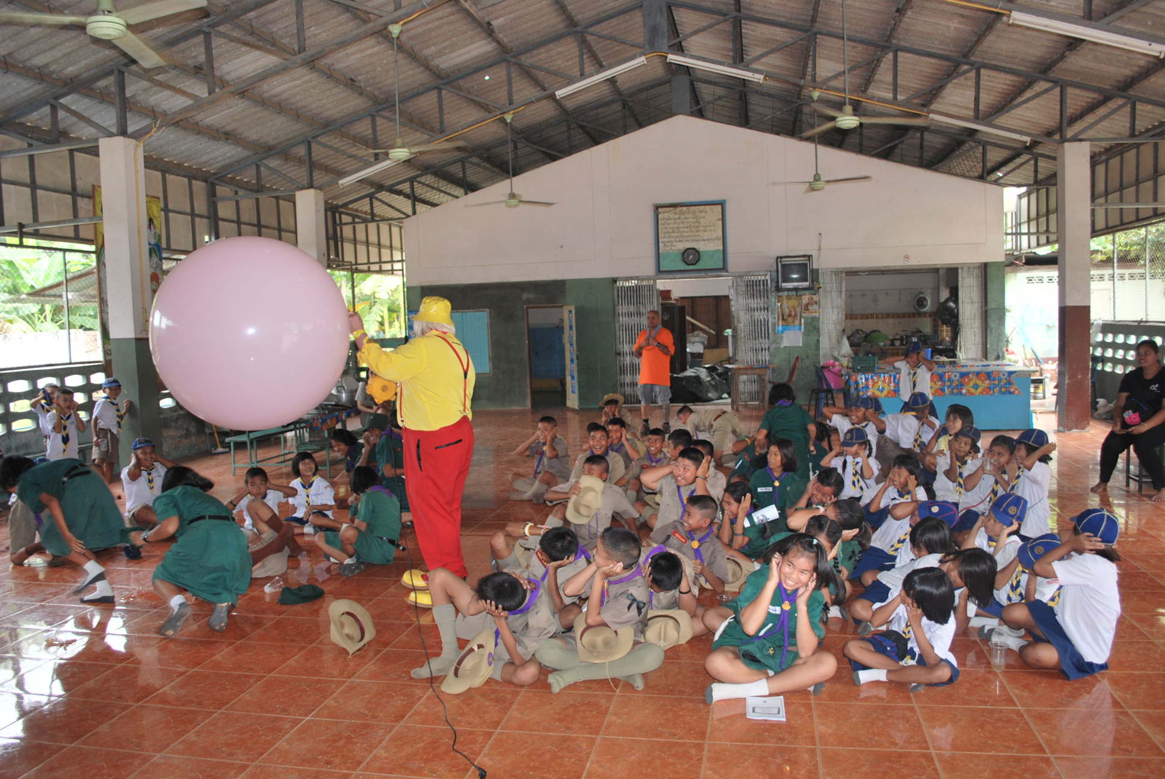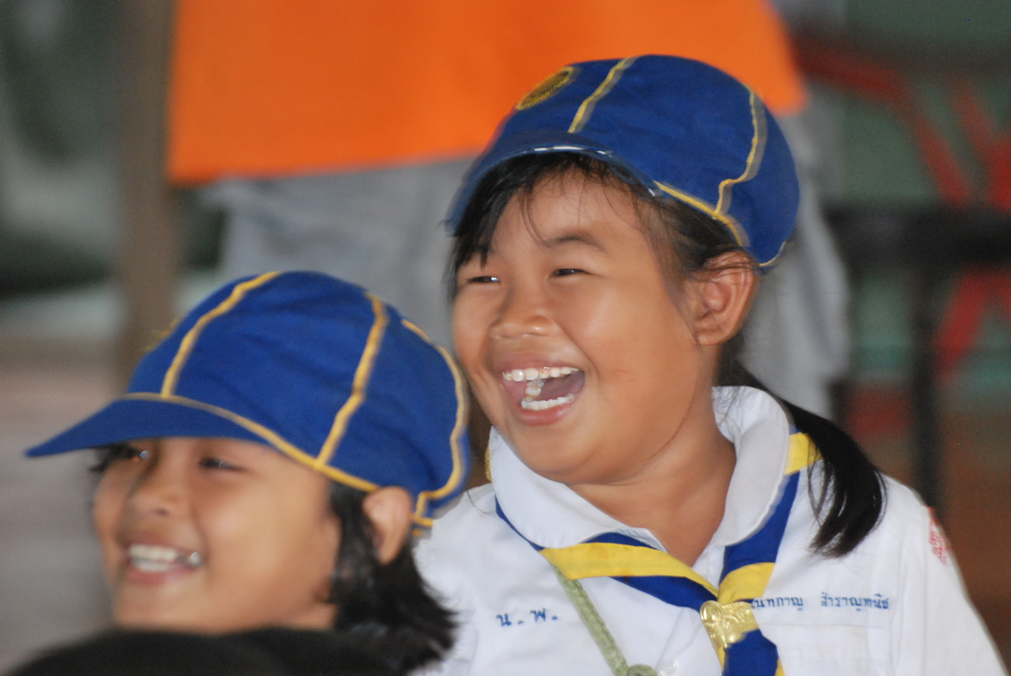

Finally on Friday, our last school this visit, was Ban Laem Yang School with 90 children 4 to 12 years. Donations of clothes for young children, teenagers and adults, toys, bedding and towels and educational equipment were handed over and naturally a madcap clown performance from Clown Eckie was thoroughly enjoyed by one and all.

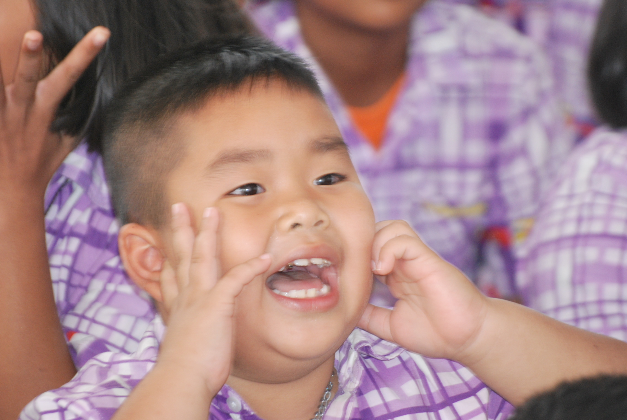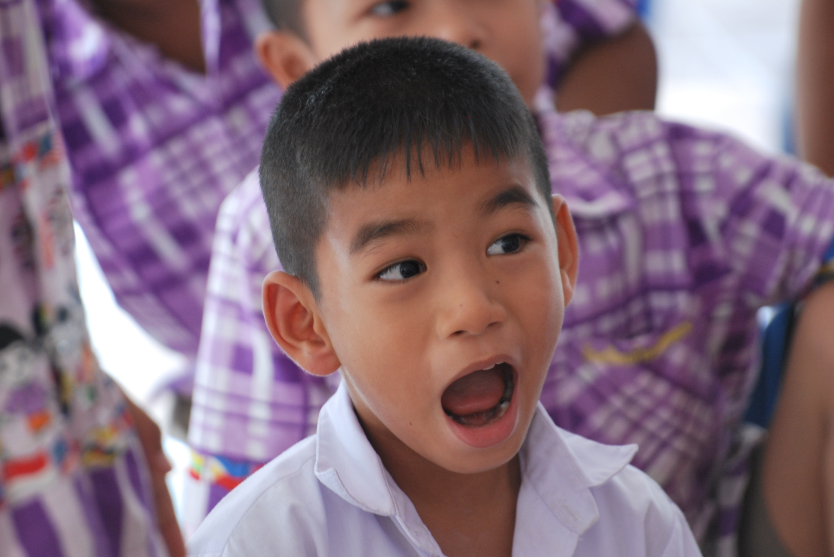

The experiment of Eddie taking his Royal Enfield to schools paid off extremely well, it provided a real focus from the moment of arrival.

Elsewhere, in the report on this project refers to Eddie’s desire to promote the wearing of suitable helmets by children EVERYTIME they ride pillion on a motorcycle – and with his arrival on his much loved Royal Enfield, he will continue to get this very important message across to teachers, parents and children.

Returning Friday afternoon gave us all time to reflect on the very positive effect the project had had on so many children and adults and the overall objective of providing HAPPINESS was certainly achieved.

